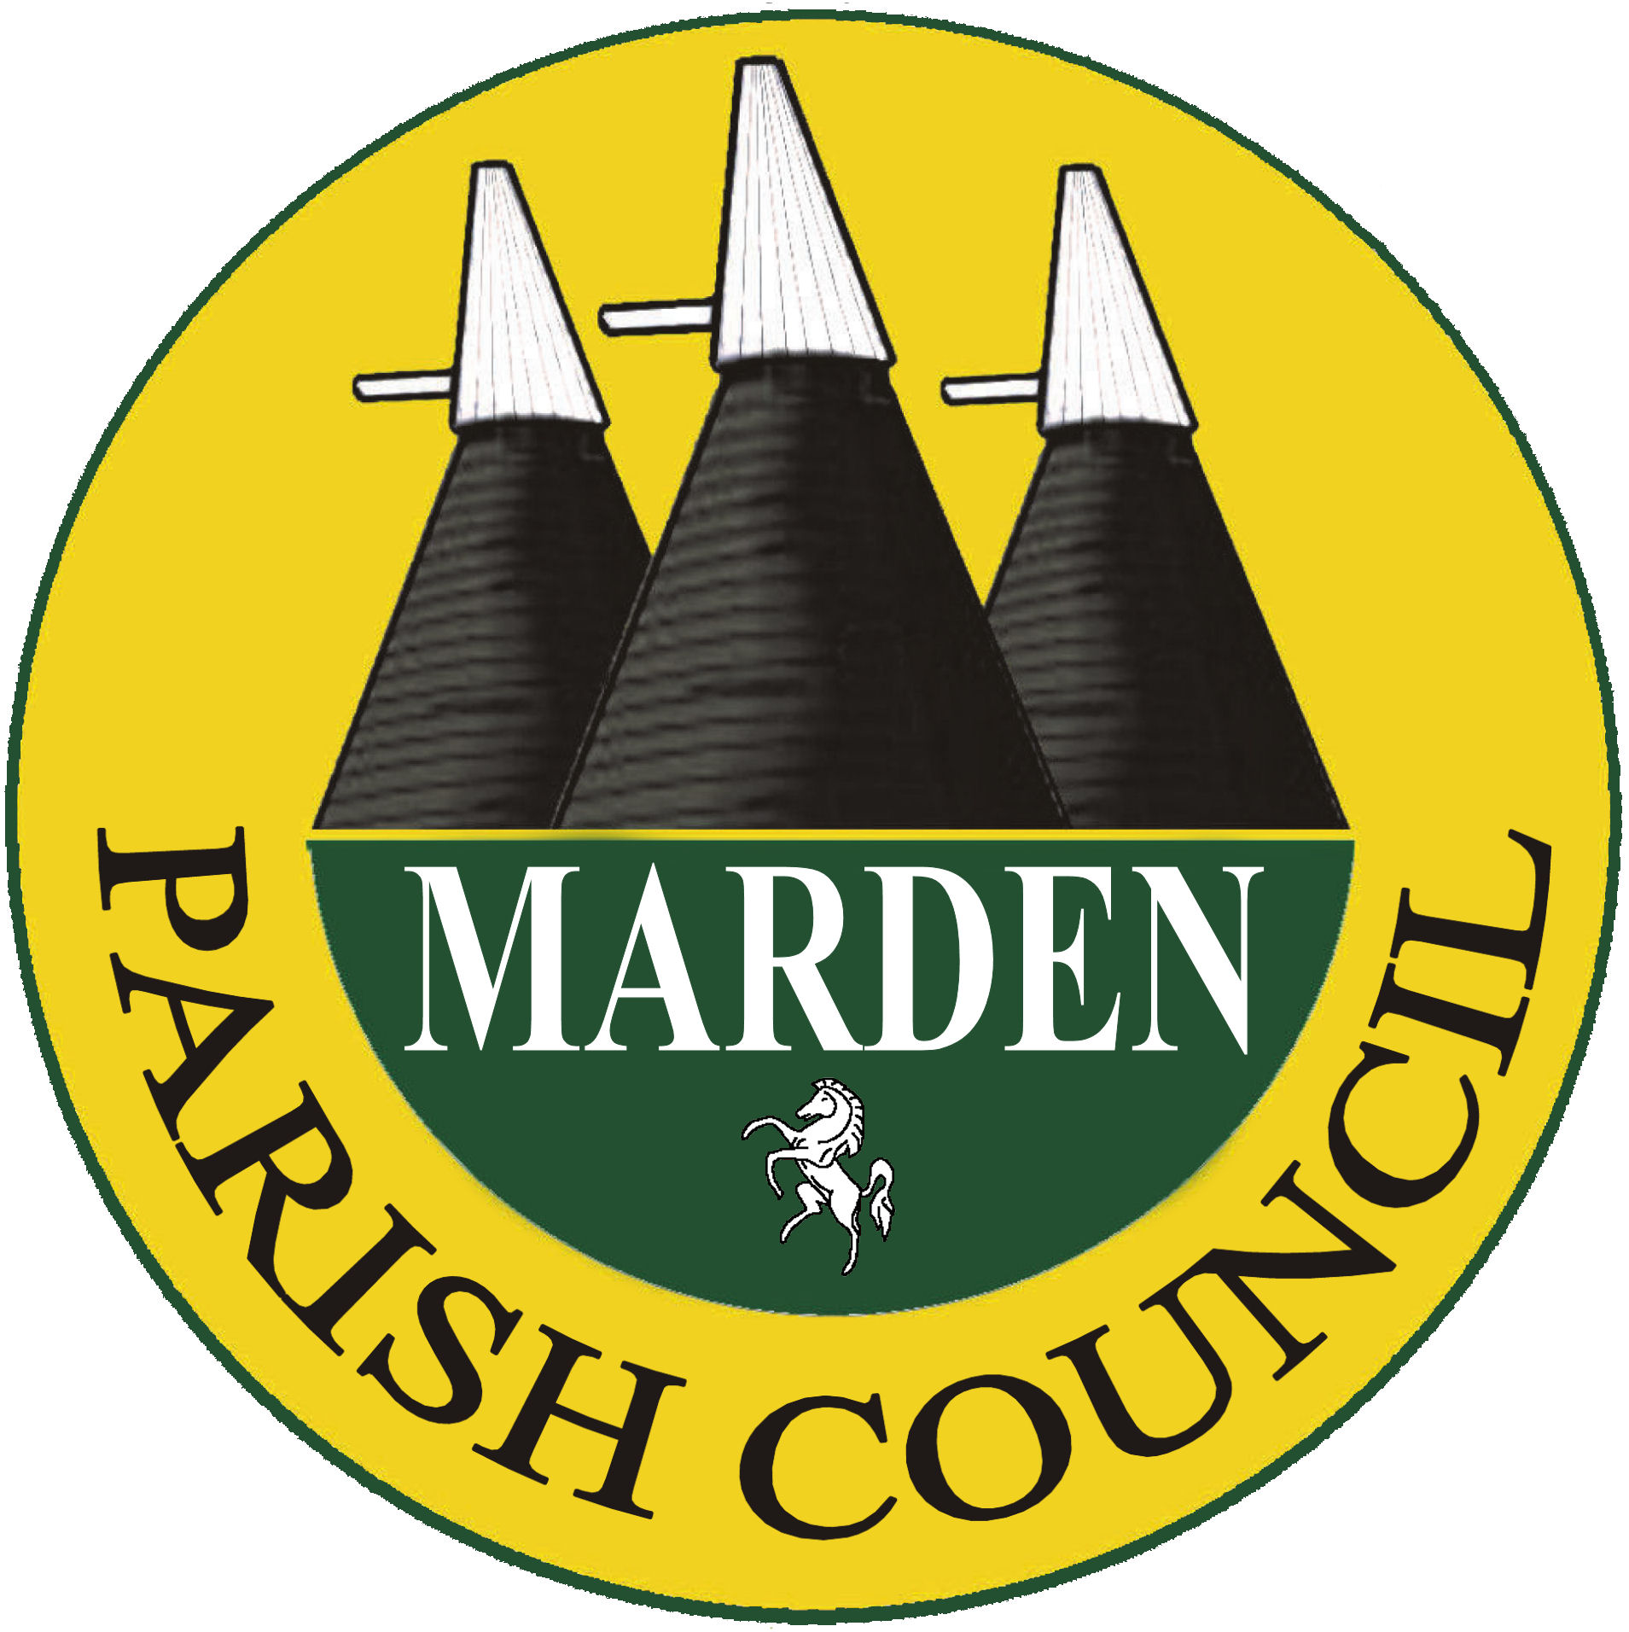
Fees for Marden Play Scheme 2023
(subsidised by Marden Parish Council)

AM (9.30am to 12.30pm)
One child | £5.00
Two children from same family | £9.00
Three children from same family | £13.50

ALL DAY (9.30am to 3.30pm)
One child | £10.00
Two children from same family | £18.00
Three children from same family | £27.00

Please do not pay until you have received confirmation that spaces are available.

Cheque (made payable to “Marden Parish Council”) or Bank Transfer – Sort Code 60-83-01 Account No. 20376138 - please use your child’s surname as reference

- - - - - - - - - - - -

During the course of Play Scheme

If booked during the course of the play scheme the same rates apply. However, space is limited and once the capacity has been reached we are unable to accept any more children.

All the above fees include a Fruit/Vegetable Cup (choice of fruit and veg) and squash/water. Water will be available to all children throughout the morning and if possible please send in a named drinks bottle to be used by your child during the course of the scheme (this will be returned on your child’s last day).

Lunch must be brought in when you child stays all day

Contact numbers:
01622 832305 – Marden Parish Council Office
07376 287981 – Parish Council mobile
(please leave a message if no reply)

